**Mohsin Mehmood, Hafeez shittu**

**ENGE 475**

**01/23/2019**

**Engineering and Motor Car**

**Background:**

Mechatronic systems have revolutionized the auto industry over the last few decades. It first started sometime during 1980s and the early 1990s. The cost of the embedded automotive electronics and the computer system passed the cost of metal used in a typical executive car. This resulted in a major business boom and provided people with more research options.

**Vehicle Mechatronic system:**

Mechatronics systems have penetrated the modern motor vehicle. This is usually not realized. Some of the examples of mechatronic systems in auto vehicle are following:

* **Engine Management:**

Mechatronics is changing the mechanical ignition timing and the fuel delivery system. This is done by software based for engine management. They help buyers, so they can diagnose and log system faults.

* **Suspension:**

Mechatronics has enabled the production of active suspension systems that can optimize comfort and road holding, which makes subtle real-tile adjustments to the suspension.

* **Brakes:**

ABS or anti-lock braking system is an example how mechatronics have improved braking in car. Abs checks rational velocity of each wheel, which helps in reducing braking efforts. Traction control and stability is the output in this system.

* **Transmission:**

Transmissions are improved over time by using mechatronic systems. This results in smooth gear changes while optimizing both performance and Fuel economy.

* **Airbags:**

Using mechatronics, multiple airbags are made possible and they can function simultaneously and they require a controller which coordinates the most appropriate response in a crash.

* **Security:**

Security is something that has improved tremendously using the mechatronics principles in an auto-vehicle. Keyless entry is made possible, it requires Bluetooth signal. Hidden GPS is added in cars to further protect it from theft.

* **Comfort, Communication and Entertainment:**

Climate control in car keeps a live check and changes the temperature in the car as needed. Driver seat positions can be saved in system, improving it for the next ride. Voice activated calls are made possible.

**Importance of Mechatronics in Motor Industries:**

Mechatronics systems have improved the motor vehicle of today in many ways. Some of the examples in result of mechatronics revolution in motor industries are following:

* **Reliability:**

Mechatronics revolution has resulted in reliable cars. This is because of the reliability of the new Electronic ignition and fuel injection system.

* **Economy and Performance:**

The mechatronic revolution has resulted in a vast market and even bigger competition in making a affordable and better performing products.

* **Security:**

Insurance constant pressure in making safer vehicles has resulted in vehicular alarm system to improve.

* **Environmental Protection:**

Carburettor systems helps in producing the lowest possible emission.

* **Safety:**

ABS brakes and traction control has been the result of mechatronic revolution and has improved vehicular safely in events like collisions and such.

**Engine Basics**

Basic operation needed to be learned before considering the automobile mechatronics system:

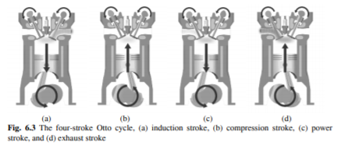

1: The rotating crankshaft at the bottom of the engine is connected to the piston and the caused it to rise and fall on cylinder.

2: The valve at the top of the engine open and closes at appropriate times in order to admit fuel to cylinder and to allow burnt exhaust gases to be expelled.

3: Most common engine uses 4 stoke Otto cycle shown is Fig 6.3.

**Engine Stroke and how it works:**

There are four basic things that happen in a simple 4 stroke Otto cycle and they are as following:

* **Induction strokes:**

With the piston moving downward in the cylinder, the valve inlet open and the air/petrol mixture is sucked into cylinder. When the piston is at bottom. The inlet valve closes.

* **Compression Stroke:**

The piston then starts to move upwards compressing the fuel mixture to about tenth of its original valve.

* **Power Cycle:**

When piston is close to the top, the spark plug ignites the fuel, causing combustion and expanding gasses to drive the piston downwards.

* **Exhaust Cycle:**

The piston rises again and the exhaust valves open to allow burnt gasses to escape.

**Conclusion:**

* Spark plug ignition must be precisely timed in relation to movement of the piston.
* The ration of air, petrol and fuel mixture must be carefully controlled.
* The valve must open and close at the exact right stage of the cycle.
* Electronic valve control is better and is an active research.

**Mechanical solution for ignition timing and fuel Delivery**

Distributor is a main component in a mechanical solution for ignition timing and fuel delivery. The purpose is to trigger a release of high voltage electricity from the coil and distribute it to the appropriate spark plug. The triggering is done by a contact breaker. 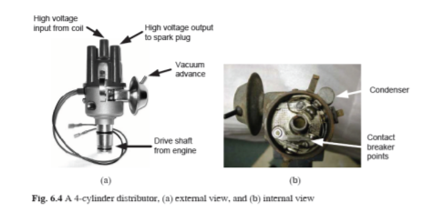

* **Fuel Delivery:**

The carburetor is used for fuel delivery. It was invented in 1895 by Karl Benz. The basic function of a carburetor is to deliver the optimum mix of air and petrol to the cylinder prior to combustion.

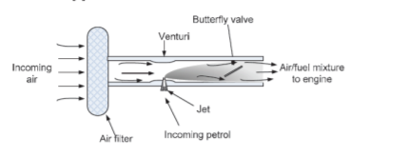

**Mechatronic Solution to Engine Management**

In order to move from mechanical systems, which are unreliable, more and more mechatronics systems are embedded in cars and some of the examples are following:

* Breaker points were replaced by non-contact sensors, called the distributor.
* The distributor uses a signal form electromagnetic transponder each time a tooth passes in front of it.
* The signal is then sorted to unelectronic ignition control unit that triggered firing of the coil and hence the spark.
* Then came the micro-processor technology, this enable complete control over both ignition and fuel delivery.

**Sensors:**

Many sensors are used now which was made possible because of mechatronic advances in this industry and some of them are as following:

* **Crankshaft and camshaft sensor:**

These are generally toothed wheel armatures passing an electromagnetic hall effect sensor. It counts the pulses that the ECU can evaluate and shows us engine speed in rpm and the actual current position of the piston and the stages in the four strokes cycle.

* **Knock Sensor:**

These are usually microphone fitted to the part of the engine, it listens for the distinctive sounds of engine knocking.

* **Lamda or Oxygen sensor:**

These sensors are placed in the exhaust to measure any burnt oxygen.

* **Throttle position sensor:**

A simple rotary potentiometer is usually connected to the end of butterfly valve in the air induction system.

* **Water temperature sensor:**

This allows ECU to detect if there is a cold start to the engine, hence enriching the fuel for stability.

**Processing:**

The ECU is used for processing the car engine’s functions and it looks like a module which consists of the following:

* All the electronics for receiving and condition the signals from the sensors.
* A powerful processor for interpreting the signals and determining the outputs.
* Outputs circuits and amplifiers for during the ignition coil and fuel injectors.
* It also has fault memory components.

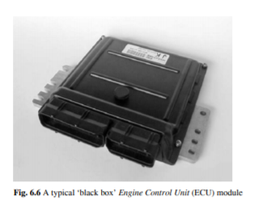

**Mechatronics and ECU**

Reprogrammable ECUs are available for car developers and in cars. The engine maps can be stored in a separate EPROM chip which is embedded within the ECU. The data is stored a table and can be seen in the picture below:

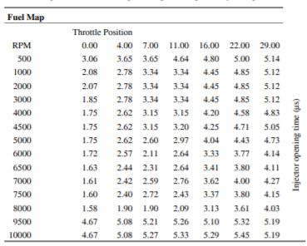

The data from the engine map table seen in the picture above are represented as a 3D surface, which can be seen in the figure below:

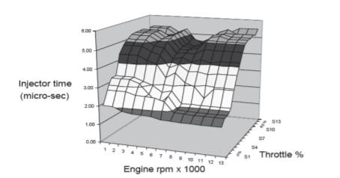

**Anti-lock Braking System (ABS):**

The system uses mechatronics system to individually control the four brakes in a vehicle, which would clearly be impossible for a human driver. This helps in following ways:

* Helping with stability
* Provides better steering response during emergencies

**ABS Components:**

The components in a ABS and their functions are as following:

1. **Hydraulic Control Valves:**

One for each wheel, these are three position valves that employ an electrical solenoid to move between positions.

1st allows fluid to pass between the brake master cylinder. (10%)

2nd position valve provides movement of the fluid between the brake master cylinder and the wheel brake cylinder. (50%)

3rd position valve current connects the wheel brakes cylinder to the return line and with the aid of a pump, can reduce the pressure at the wheel.

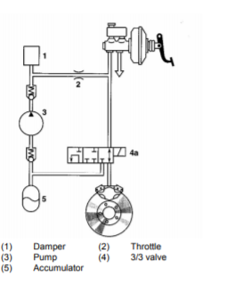

**Wheel Speed Sensors:**

This consists of an electromagnetic proximity sensor fixed in a stationary position to the wheel. The sensor is positioned about 1mm from the rotating toothed ring which is connected to the moving wheels shaft. When each tooth passes the sensor, this send a signal to ECU and is recorded.

**Electronic Control Unit:**

This has following major sub-system:

* **Input Circuits:**

This conditions the signals from the wheel speed sensor and forwards them to one of the micro-controllers.

* **Micro-controllers:**

There are two identical but separate integrated circuits, each one connected to two diagonally opposite wheels.

* **Open circuits:**

In response to commands from the microcontrollers, two stage output circuits use power transistors to amplify the signals. This provides enough current to energize the solenoids on the hydraulic valves.

**Reference:**

<https://www.google.com/url?sa=i&source=images&cd=&cad=rja&uact=8&ved=2ahUKEwjthMSq1oTgAhXpV98KHf8GAjUQjRx6BAgBEAU&url=https%3A%2F%2Fwww.elprocus.com%2Fdifferent-microcontrollers-used-in-automobiles%2F&psig=AOvVaw2ssXmkKQAMlz7T4HNs5st4&ust=1548359356185930>

<https://www.machinedesign.com/mechanical/improving-car-engines-advanced-variable-hydraulic-valves>

<https://www.edn.com/electronics-blogs/bakers-best/4392026/Instrumentation-amplifier-input-circuit-strategies>

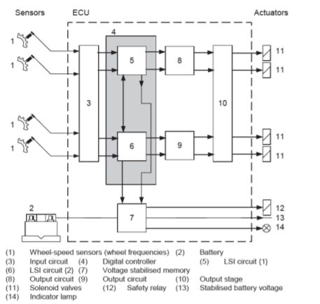

**ABS Diagnostics:**

Using mechatronics provided us with a system which has a great diagnostic functionality. It can operate at several stages of the valve operations:

* Abs system will be disabled and a warning light will be illuminated in the dashboard when the open circuit exists in the system.
* All the details of errors and defects are recorded as a fault memory.

**Conclusion:**

* The mechatronics advances improved auto industry.
* The cars are safer because of sensors.
* The ECU is a powerful module and functions as a processor of engine related functions.
* Anti-lock braking system has improved the safety of the vehicles over time.